A Guide to the Cretaceous Dinosaurs and Sea Monsters of Alabama

Late Cretaceous Geology of Alabama
Although Alabama has one of the most complete geologic sections in the United States, we are missing the first 3/4 of the Mesozoic Era, commonly known as "The Age of Dinosaurs.” Alabama does have rocks from the first two of the three periods of the Mesozoic, the Triassic and Jurassic Periods, and from the Early and Middle parts of the Cretaceous Period, the last of the three time periods that make up the Mesozoic, but they are buried beneath thousands of feet of younger rocks in south Alabama. The only rocks from the Mesozoic that occur at the surface in Alabama are those of the Late Cretaceous, with fossil ranging in age from 85 to 65 million years old.
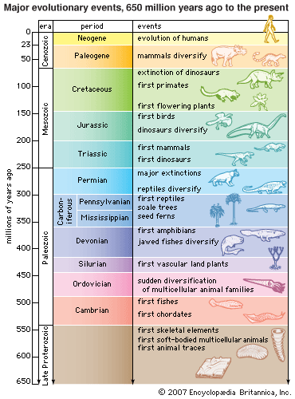

In Alabama, rocks of Late Cretaceous age outcrop in a narrow east-west trending band across the central part of the state, commonly referred to as the "Black Belt" (due to the rich black soil that is produced from the weathering of the rocks). Fossil-bearing rocks in this area are all marine in origin. Although there are older Late Cretaceous rocks in Alabama that were deposited in freshwater and associated terrestrial settings, they are largely unfossiliferous.

Distribution of Late Cretaceous rocks in Alabama.

The Late Cretaceous rock formations in Alabama are largely composed of Chalk. Chalk consists primarily of the limy-fossilized skeletons and body parts of microscopic organisms that lived in the rich Cretaceous seas. The name Cretaceous, itself, is derived from the Latin word for chalk. Chalk contains many tiny plates of calcium carbonate (calcite) produced by marine algae known as coccolithophorids. Other important microscopic fossils found in chalk are the foraminifera, or “forams.” These minute marine creatures also build protective skeletons of calcite that become visible under high magnification.
The oceans today cover almost 71% of the earth’s surface. About 20% of the oceans lie over the shallower continental margins, while the rest covers the deeper ocean floor, which is blanketed by a variety of sediments. Amongst these are what is known as oozes, so-called because more than 30% of the sediment consists of the shells of microorganisms such as foraminifera and coccolithophores. About half of the deep ocean floor is covered by light-colored calcareous (calcium carbonate-rich) ooze generally down to depths of 4,500–5,000 meters. Below these depths the calcium carbonate shells are dissolved. Even so, this still means that about one quarter of the surface of the earth is covered by these shells — rich deposits produced by these microscopic plants and animals living near the surface of the ocean.
Geologists believe that these oozes form as a result of these microorganisms dying, with the calcium carbonate shells and coccoliths falling slowly down to accumulate on the ocean floor. It has been estimated that a large 150 micron (0.15mm or 0.006 inch) wide shell of a foraminifer may take as long as 10 days to sink to the bottom of the ocean, whereas smaller ones would probably take much longer. It is via this slow accumulation of calcareous ooze on the deep ocean floor that geologists believe chalk beds originally formed. A sugar-cube sized piece of chalk contains an estimated 3 billion individual coccoliths!

The Late Cretaceous climate in Alabama
During the Late Cretaceous, the climate was one of the warmest in Earth’s history. This was a result of a variety of factors including:

1) The continents were in different positions so that a world-spanning equatorial ocean current distributed warm ocean water even as far north and south as the poles.
2) Atmospheric carbon dioxide was approximately 4 to 6 times modern levels.
3) Increased area covered by oceans (melted ice caps). Water retains heat from the Sun more efficiently than land.

The combination of these and other factors resulted in a climate so warm that there were no glaciers or ice caps anywhere on Earth, and all of that ice volume was added to the oceans as water. This resulted in the second highest sea level in all of Earth's history, and flooded about 1/3 of the present day land surface with shallow seas. In North America, the Western Interior Seaway extended from the Gulf of Mexico to the Arctic Ocean. This divided North America into a western half, known as Cordillera, and an eastern half, known as Appalachia. Cordillera and Asia were still connected by land, and to a lesser extent Africa and Europe were connected. However Appalachia was completely isolated from other dinosaur populations, so the Late Cretaceous dinosaurs that lived in what is now the Eastern U.S. are unique, having evolved in isolation for some 30 million years.
A variety of evidence indicates that hurricanes, which derive their energy from sea surface temperatures, were a common phenomenon. They basically followed a course similar to the present day track of hurricanes, but seem to have most often moved through the Gulf of Mexico and straight up the Western Interior Sea, all the way to present day Canada. This track brought them right over central Alabama.
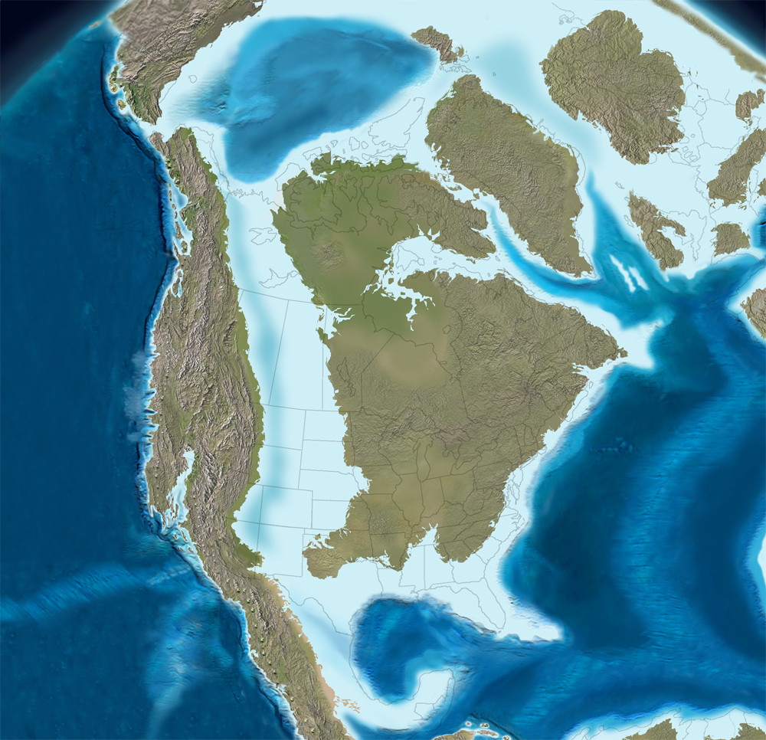

North America 85 million years ago.

Alabama Sea Monsters
During the Late Cretaceous, the southern half of Alabama was covered by a warm shallow ocean. Teeming with life, the shallow sea in Alabama was full of monstrous creatures which included:

Mososaurs (moe-sa-sawrs)
Alabama is among the best places in the world to find mosasaur fossils. Mosasaurs are marine reptiles that lived during the time of the dinosaurs. Many species of mosasaur once swam in Alabama’s ancient sea. Paleontologists are able to differentiate between these species by their different sizes and slightly different skull and skeletal structures. A few of these species of mosasaurs could grow to enormous sizes, some exceeding 50 feet!
Mosasaurs were at the top of the food chain and preyed on smaller individuals of other species, including ammonites, fishes, birds and even smaller mosasaurs. Mosasaurs had to surface periodically to breathe. Instead of an "up and down" movement their tail like whales and porpoises, mosasaurs used a sinuous, undulating movement of their tails to propel themselves rapidly through the water. This movement would have been much like that of a swimming alligator or snake. Mosasaurs could flex their lower jaws allowed it to swallow prey in one piece (much like modern-day snakes). Mosasaurs gave live birth to their young and may have even provided them some form of parental protection.
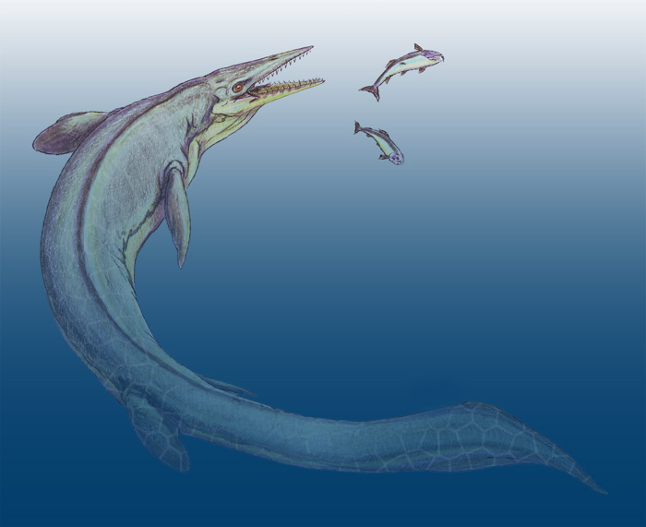

Cretoxyrhina (kree-tox-ee-rye-nuh)
Cretoxyrhina was the largest shark in the Cretaceous Sea, some reaching a length of twenty feet or more. Their teeth are long and smooth and can measure over two inches. It was undoubtedly a ferocious predator. Probably not closely related to the Great White of today, although a close ecologic analog. Cretoxyrhina teeth have been found in skeletal remains of the mosasaur Tylosaurus, although there are no specimens that indicate whether this was the result of in-life confrontations or scavenging of a dead carcass.

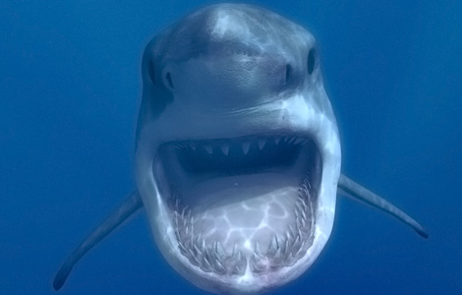

Pachyrhizodus (pack-ee-rye-zo-dus)
Pachyrhizodus is a Cretaceous fish that is represented in Alabama by three different species. Pachyrhizodus caninus is the largest variety reaching lengths up to eight feet. It had a robust skull with large, curved teeth. The jaws of this fish have been mistaken for small mosasaur jaws. Pachyrhizodus minimus is the smallest species of the genus, seldom reaching over three feet. This fish is noted for dense, compact scales.

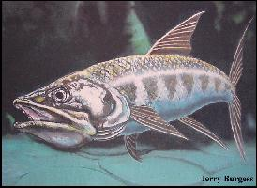

Xiphactinus (zai-fact-in-us)
Xiphactinus was the largest bony fish in the Late Cretaceous, sometimes reaching a lengths up to eighteen feet. They are sometimes compared to the modern tarpon though no real evidence exists to support this relationship. They became extinct at the end of the Cretaceous period. These huge fish, along with mosasaurs, were ferocious predators. Xiphactinus means “sword-ray” and was named from a piece of a front (pectoral) fin. It is equipped with fang teeth, some over two inches long, and had jaws like a huge piranha.

Xiphactinus had a voracious appetite and often ate fish whole and head first. Greed sometimes got the best of them and some died with a meal inside. The world famous “Fish within a Fish,” collected by George F. Sternberg in 1952 and on display at the Sternberg Museum of Natural History in Hays, Kansas is a classic example of this (see below). The fourteen-foot Xiphactinus swallowed a six foot Gillicus fish and died as a result of its gluttony. Although they were fierce predators they were eaten by large mososaurs and sharks.
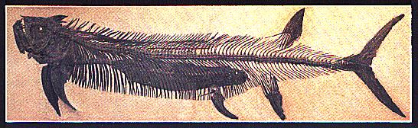

Protestega (pro-toe-steg-a)
This extinct sea turtle could grow up to 13 feet in length and is the 2nd largest sea turtle to have ever lived. Female Protestega periodically migrated hundreds of miles, similar to leatherback turtles, to lay their eggs on sandy beaches. The shell of Protostega was not solid. It was made of a thick web of bone, which served to reduce its weight. It could not retract its body into its shell. Instead it would use its large and powerful front legs to get away from predators.
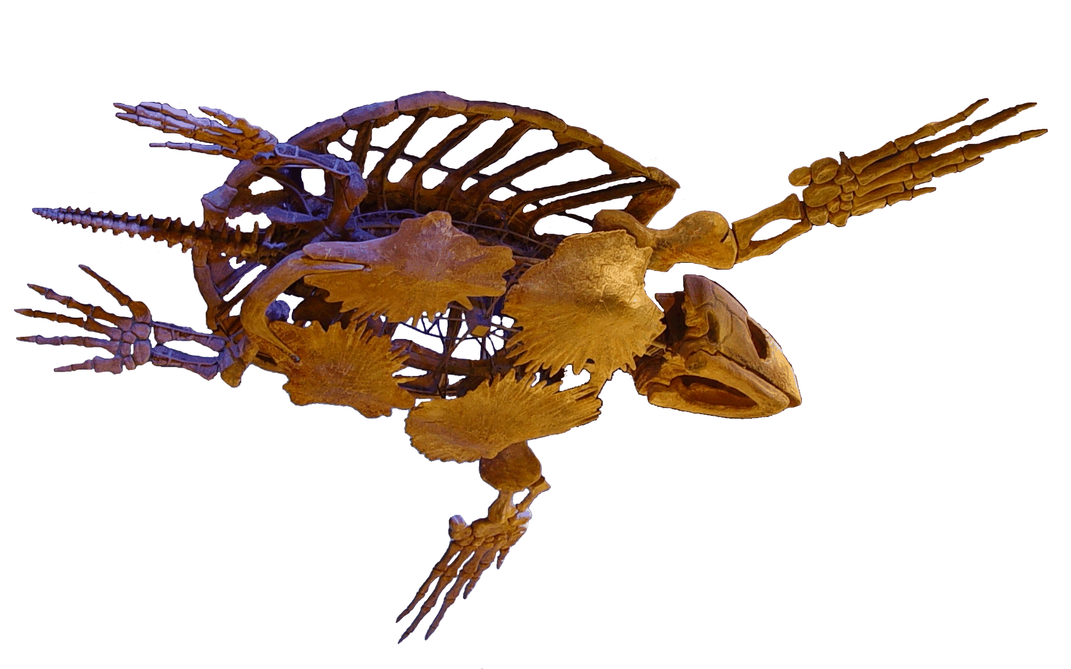

Alabama Sea Monsters
The Late Cretaceous rocks that are exposed in Alabama today are nearly all marine in origin. This means that all of the dinosaurs and other land-based animals represent the carcasses of dead animals that filled with decomposition gases and floated down rivers and out to sea before sinking. In many cases shark scavenging may have been the thing that ruptured the body cavity allowing the carcass to sink to the sea floor, as many bones of these animals bear deep scratches and cuts that match sharks teeth. Occasionally shark teeth are even found embedded in the bones. Once the carcass came to rest on the sea floor, a variety of scavengers such as sharks, fish, crabs, and worms reduced the carcass to a skeleton, often scattering the bones. If the skeleton came to rest in shallow waters, hurricane-driven storm currents could rearrange the bones, in a manner similar to the way modern-day storms sometimes uncover old shipwrecks. Analyzing the patterns created in storm-arranged skeletons can in fact help establish the presence of storm systems in the Late Cretaceous as well as indicate the direction from which major storms struck the coast.
The Late Cretaceous forests in Alabama represented a time when old types of plants that had long dominated the Mesozoic were giving way to the Angiosperms (flowering plants). The flowering plants comprise the vast majority of plant species on earth today, but were just evolving in the Cretaceous. About 40% -60% of the forests appear to have been composed of flowering plant species, with the remainder composed of ferns and allied plants, including tree ferns, and the Gymosperms, the group to which conifers belong. Pine trees seem to have been confined only to the western edge of the state.
The discovery of dinosaurs in Alabama is extremely rare. However, all of the dinosaurs that have been discovered in Alabama and named have represented new species. However, many of the dinosaur types known from are still awaiting formal descriptions meaning they have not yet been named. The known types of dinosaurs in Alabama include:

Appalachiosaurus montgomeriensis (ap-a-lay-chi-o-sawr-us munt-gum-er-e-in-sis)
The name of this dinosaur "appalachian dinosaur from Montgomery" - an allusion to the fact that it comes from the Late Cretaceous Appalachia division of North America, and was found in Montgomery County, Alabama. Appalachiosaurus is closely related to the Tyrannosauridae, the family of theropods (meat-eating dinosaurs) to which Tyrannosaurus rex belongs. There are hints that early tyrannosaurs in various parts of the world did not have the tiny, two-fingered arms of the later tyrannosaurs like T. rex, Albertosaurus, Daspletosaurus, etc., but rather had the more typical theropod build of a large arm and three fingers. Because of the separation of Appalachia, Appalachiosaurus had evolved from a primitive tyrannosaur stock and still retained a large arm. In fact, although T. rex was fully twice the body size of Appalachiosaurus, it had an arm 1/2 the size of an Appalachiosaurus arm. While the tiny arms of T. rex have given rise to a debate about whether it was an active hunter or a scavenger, there seems little doubt that Appalachiosaurus was a capable hunter.
Like other tyrannosaurs, Appalachiosaurus teeth have strong serrations - notching like the teeth along the cutting edge of a handsaw. Experiments have shown that these serrations trap meat fibers and it is likely that Appalachiosaurus had a nasty fauna of microbes growing in its saliva. A bite from a tyrannosaur could probably induce massive infection. A well-tested mathematical formula allows paleontologists to determine the speed of an extinct animal from a set of preserved footprints - a trackway. A medium-sized theropod like Appalachiosaurus was probably capable of running 25 miles an hour. That's olympic class sprinter speed, but because theropods seem to have had the same flow-through "turbo lung" design as birds, they likely had great endurance to go with that speed.

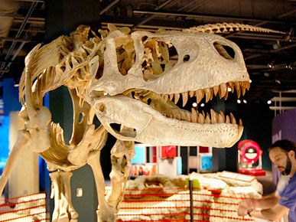

Dromaeosaurs (drome-e-oh-sawrs) - unidentified species
Dromaeosauridae is the family of theropods that include Deinonychus - the villains of the Jurassic Park movie (even though they incorrectly called them Velociraptor, presumably because they thought the name was more cool; and they made them too big). The discovery of Deinonychus in the late 1960's is widely credited as the launching point of our present understanding that dinosaurs were not slow, lumbering, dumb brutes. Obviously built for speed and sporting an enlarged, retractable, switch-blade killing claw on their hind feet, there was no way this animal fit the old ideas. Dromaeosaurs are the specific group of theropods thought to be most closely related to birds, sharing with them over 100 skeletal characters, and chemically identified remains of feathers. Dromaeosaurs are known from Alabama, but to date no remains complete enough for identification have been found.
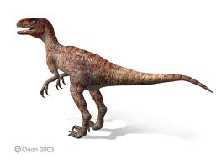

Ornithomimid (or-nith-o-my-mid) – unidentified species
Ornithomimid means "bird mimic," due to the similarity of the skeleton to that of a bird. Dinosaurs and birds are actually closely related. Birds are essentially flying theropods, or looked at another way, birds are the only group of dinosaurs to survive the end Cretaceous extinction.
Ornithomimids are known from Alabama, but to date no remains complete enough for identification have been found. The few bones that have been found indicate that the southeastern ornithomimids were large -up to 16 feet in length. Ornithomimids were very fast, built from the hips down much like a modern ostrich, which can attain speeds of up to 46 miles per hour - faster than a modern Greyhound or White-tailed deer. To help absorb the force of the foot hitting the ground at such speeds they have a shock-absorber built into their foot. We don't know exactly what ornithomimids ate. Gastroliths (gizzard stones) suggest a plant diet, but one study of the isotopes of preserved organic molecules suggests they ate more than plants. They may have been omnivores.

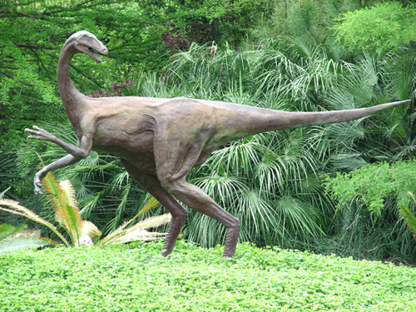

Nodosaurs (no-do-sawrs) - unidentified species
Nodosaurs are known for their boney nodules or "nodes" of bone found within their skin. These nodules of bone in most species are modified into side and shoulder spikes and armor plates. Some species even have fused "skin armor" onto their skulls. Unlike their close relatives the ankylosaurs, nodosaurs did not have a tail club, but made up for this with heavier and more extensive armor and side spikes. Nodosaurs were herbivores. Their tank-like build prevented them from feeding much higher than about 2 feet off the ground, so they likely feed on things such as ferns, which formed the ground cover during the Mesozoic (there was no grass then). This means that Lophorhothon and nodosaurs could graze side by side without competing for the same food resources. Imagine some of the mixed herds of zebras and gazelles on the plains of Africa congregating for mutual defense and you can form a mental picture of the same thing happening during the Late Cretaceous in Alabama. Individual nodosaur bones are occasionally found in Alabama, and unfortunately the only set of associated remains are incomplete and from a very young animal, making identification difficult. Nodosaurs have the somewhat dubious distinction of having the second smallest brain weight to body weight ratio of any dinosaur - only sauropods were dumber.

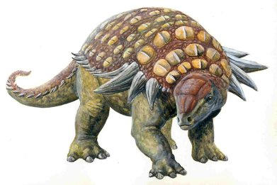

Lophorhothon atopus (low-fo-row-thon)
Lophorhothon meaning "out of place crest" - an allusion to the fact that the crest on the "nose" region of the skull is in an unusual position. Lophorhothon was the most common dinosaur from Alabama and lived in vast herds like modern American bison. Lophorhothon was an herbivore. It possessed a mouth lined with banks of hundreds of baseball-diamond-shaped teeth, each with a strong, sharp ridge running down the center. These teeth formed a compound file or rasp-like chewing surface, allowing the animal to thoroughly grind up even tough plant material. Like all dinosaurs, it replaced teeth throughout its life.

