Lesson Plan: Across Time and Space

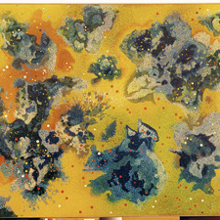
Blue Mysteries Near the Sun, No. 4
Vance Kirkland, United States
1976

Overview
Students will learn about different dates/events in the exploration of time and space, including meteorites, asteroids and comets, using the painting Blue Mysteries Near the Sun, No. 4 as a jumping off point. The activities will allow them to use their historical imaginations and inquiry skills to better understand time and sequencing of events. An optional visual arts project can finish off the lesson.

Age Group
Elementary (grades K-5)

Standards
21st Century Learning Skills Addressed:
- Critical Thinking and Reasoning
- Information Literacy
- Collaboration
- Self-Direction
- Invention
Alabama Academic Standards Primary Area Addressed:
Social Studies
History
- Analyze historical sources using tools of a historian
- Become familiar with United States historical eras, groups, individuals, ideas and themes
- Understand chronological order of events
- Ask questions, share information and discuss ideas about the past
Additional Alabama Academic Standards Addressed:
Visual Arts
- Observe and Learn to Comprehend
- Invent and Discover to Create
- Relate and Connect to Transfer
Language Arts
- Oral Expression and Listening
- Reading for All Purposes
- Writing and Composition
- Research and Reasoning

Length of Lesson
One 50-minute lesson

Rationale
Discussing the timeframe in which an artist is/was working, coupled with the works he created, lays a framework to understand both the artwork and chronology related to space exploration. These types of activities allow students to develop their critical thinking and historical inquiry skills.

Objectives
Students will be able to:
- identify the correct order, century, and decade of at least three of the following events: invention of the telescope, launch of Sputnik, first animal in space, first human in space, landing on the moon, first use of large mirror telescope, launch of the Hubble Space Telescope, meteorites, asteroids and comets; and discuss how the time in which a person lives influences their ideas and artwork.

Materials
- Images of a naked-eye view of the night sky, and a Hubble Telescope view in space
- Internet links or printed copies of articles/headlines about space exploration and space travel
- About the Art sheet on the Blue Mysteries Near the Sun, No. 4 (found at the end of thie lesson plan) or student access to this part of Creativity Resource online
- One color copy of Blue Mysteries Near the Sun, No. 4 for every four students, or the ability to project the image onto a wall or screen
Optional: Color pens or pencils and paper

Lesson
- Teacher Preparation: Read the “Things to Look For” section of the About the Art sheet.
- Warm-up: Have students imagine a planet, galaxy, or star that humans have not yet explored. What might it look like? What colors and characteristics would it have?
- Show students the painting and lead a discussion about it, using information from the “Things to Look For” section of the About the Art sheet as a guide.
- Share the title of the painting and discuss how it relates to the task they completed in the warm-up activity. Talk about when the artist was born and the time period during which he grew up. Share that he lived in a time before satellites were launched into space, when man’s only view of the stars came from Earth (refer back to the warm-up activity to get a sense of empathy). Show images of a naked-eye view of the night sky.
- Either using information you provide or allowing students time for research, have students make a timeline of space exploration and travel from the time of Vance Kirkland’s birth (1904) until he painted this piece (e.g., invention of the telescope, launch of Sputnik, first animal in space, first human in space, landing on the moon, first use of large mirror telescope, launch of the Hubble Space Telescope).
- Show the students images from the Hubble Space telescope. Compare these images with the painting. Talk about their similarities and differences; how the artist captured something that had been hinted at in his time, but only later confirmed through technological developments.
- If you have time, let the students draw pieces inspired by their imaginations and the images of space that you shared.

About the Art

Blue Mysteries Near the Sun, No. 4 by Vance Kirkland, United States, 1976

Who Made It?
Vance Kirkland made more than 1,000 paintings during his 54-year career, although he got off to a bit of a rough start. Born and raised in Ohio, Kirkland attended the Cleveland Institute of Art where as a freshman he failed his watercolor class. His professors complained that Kirkland’s colors “fought” each other and did not exist in natural landscapes. After graduating, he moved to Denver, where at the age of 24 he was invited by the University of Denver to establish an art school. A few years later, he left the university and founded the Kirkland School of Art on Pearl Street in Denver, which is now the site of the Kirkland Museum. Kirkland was an active supporter of the arts community in Denver. He died in 1981.
Kirkland spent the early part of his career painting traditional landscapes. His paintings soon began to take on a more mystical appearance as he began incorporating imaginary forms into nature. Kirkland switched gears again in 1954 and spent the rest of his painting career imagining the visual possibilities of space. He said, “I think it is the unknown things that fascinated me all the way along—to visualize what might have happened billions of years ago as things exploded in the universe.”

What Inspired It?
In 1954 Kirkland began painting what he called his “Energy in Space Abstractions.” At the time, much remained unknown about the conditions and quality of outer space, which left Kirkland free to depict space any way he could imagine: “My idea of trying to visualize all the things that have been happening in space over 25 billion years gives me the freedom of imagination without being tied down to any exact image of reporting nature. It may come from nature but it’s not the nature we are sure of. It’s a guess kind of nature. These are imaginary events that might have happened, not actual events.”

Things to Look For

Blue Mysteries Near the Sun, No. 4 by Vance Kirkland, United States, 1976

Color
Kirkland liked to use contrasting colors. He chose vibrant colors that he felt captured the movement and energy that he imagined to be in space. He said, “I limit myself to those color combinations which seem to vibrate and can, therefore, form illusions of floating mysteries of explosions of energy in space.”
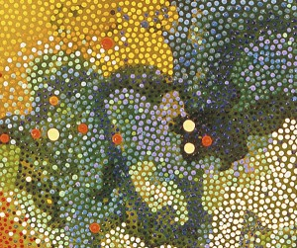
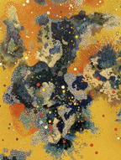

Shapes
The cloud-like organic forms that Kirkland scattered across the canvas are irregular in color and shape. They might represent the aftermath of an explosion or clouds of gases floating in space.
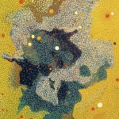

Movement
Irregular shapes and varied color may suggest sudden movement or expansion. Areas of green that seem to seep in on the left and lower right edges might appear to some viewers as a scattering or joining of gases or energies.
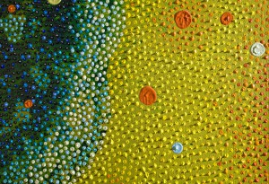

Dots
Kirkland tried to create the effect of many layers, or fields of energy, in his depictions of space. Red, white, blue, orange, and yellow dots are layered over the cloud-like shapes. Kirkland kept a collection of unconventional tools, such as wooden dowels, twigs, and paint brushes with the hairs of the brush cut off, to create precise dots of contrasting colors. To paint these precise dots, Kirkland fashioned a sling that he suspended above the canvas he was working on. Lying in the sling, he hovered over the painting, moving the canvas (which he placed on top of a skateboard) beneath him so he could reach any section of the painting he wished to work on.
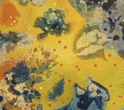

Perspective
Kirkland’s paintings are like little universes within themselves, with no fixed points of reference, and they leave room for countless interpretations. In fact, some of Kirkland’s paintings, like this one, are not signed, while others have two signatures, so that the painting can be hung in multiple ways. Which way is up? Which way is down? How far away are we from the cloud-like shapes? Is direction even relevant in space?
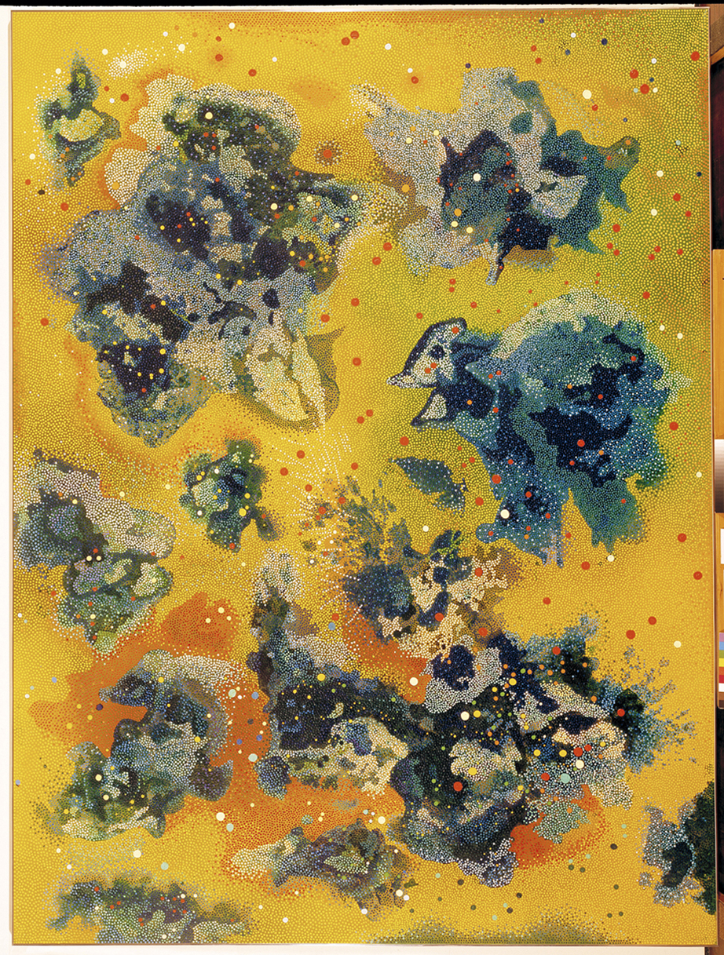
Blue Mysteries Near the Sun, No. 4
Vance Kirkland, United States
1976

