Lesson Plan: Jamming and Fishing
Skull and Roses/Grateful Dead, Oxford Circle, Avalon Ballroom, San Francisco
Alton Kelley and Stanley Mouse, United States
1966

Overview
Students will learn the creative processes behind Kelley and Mouse’s poster Skull and Roses/Grateful Dead, Oxford Circle, Avalon Ballroom, San Francisco: inspiration from others in the present, creativity “jams,” and artwork found by “fishing in the past.” They will then use these strategies to work in groups to create their own posters.

Age Group
Elementary (grades K-5)

Standards
21st Century Learning Skills Addressed:
- Critical Thinking and Reasoning
- Information Literacy
- Collaboration
- Self-Direction
- Invention
2009 Colorado Academic Standards Primary Area Addressed:
Visual Arts
- Observe and Learn to Comprehend
- Envision and Critique to Reflect
- Invent and Discover to Create
- Relate and Connect to Transfer
Additional 2009 Colorado Academic Standards Addressed:
Language Arts
- Oral Expression and Listening
- Reading for All Purposes
- Writing and Composition
- Research and Reasoning

Length of Lesson
One 45-minute lesson (could be extended to two periods)

Rationale
One of the best ways to learn anything is through modeling. By studying Kelley and Mouse’s creative processes, students learn about an effective model to use when they have to come up with their own ideas and products. This particular model also reinforces the concept that creativity does not mean doing something entirely by one’s self.

Objectives
Students will be able to:
- describe what Kelley and Mouse meant by “jam” sessions and “fishing in the past”;
- discuss the importance of teamwork, communication, and creative problem solving;
- work in small groups to complete a task; and
- feel comfortable enough to draw a sketch to the best of their ability.

Materials
- Printed copies (or the ability to print copies from books or online sources) of old advertising images and/or art (You can find some examples here, but be sure to preview and print out images as there is some potentially sensitive material)
- 11x14 or 11x17 paper (at least 4 sheets per group)
- Colored pencils
- Scissors
- About the Art sheet on Skull and Roses/Grateful Dead, Oxford Circle, Avalon Ballroom, San Francisco (found at the end of the lesson plan) or student access to this part of Creativity Resource online
- 1 color copy of the poster for every 3 students, or the ability to project the image onto a wall or screen

Lesson
- Warm-up: Play “People Machine.” Divide the class into three even groups; each group will come up to the front of the class one at a time. The students should wait on one side of the front of the class. One student at a time comes to the center and makes a motion and a sound, such as that made by a machine. He/she will continue to do so as all of the other students work in their motion and sound in connection to the other student until everyone in the group is part of the machine. Allow the other groups to go. Talk about how they had to work together in order to add their part: they had to watch what the other kids were doing and listen to the sounds they were making.
- Share how artists often do the same thing – work together and draw upon the ideas of others. Read quotations from Kelley and Mouse about the “fishing in the past,” wanting to be more creative when they saw the creativity of others, and the “jams.”
- Show them the poster and talk about its history.
- Divide students into artistic groups of two to four students. Have groups decide on something they want to advertise, and how they want to communicate their message. Then give them time to look through old advertising or artistic images to incorporate in their pieces.
- Each group should present a final poster. Remind them that Mouse had his “hand” in most of the artwork but that he and Kelley worked as a team.
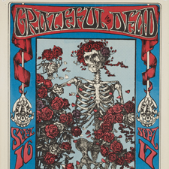

About the Art

Skull and Roses/Grateful Dead, Oxford Circle, Avalon Ballroom, San Francisco by Alton Kelley and Stanley Mouse, United States, 1966

Who Made It?
This poster was made through the collaborative efforts of two artists—Stanley “Mouse” Miller and Alton Kelley. Mouse was raised in Detroit and got his start designing graphics for hot rods and motorcycles. He left Detroit in 1965, at the age of 25, and headed to California. He arrived in San Francisco on the evening of the Trips Festival, a three-day multimedia event that set the stage for later dance concerts. It was the handbill for this event that led to Mouse’s interest in poster art: “I was really turned on by that lettering and I found out later that Wes Wilson had done it. That’s what really inspired me to start doing posters.”
After arriving in California, Mouse met Alton Kelley and the two came together to form Mouse Studios. Kelley had begun his artistic career drawing posters and handbills for dance parties put on by the Family Dog commune, a group of hippies living in San Francisco. While Mouse was responsible for lettering and drawing, Kelley usually chose the image they would use and laid out the design. At their studio, Mouse and Kelley often hosted poster-making “jams” where groups of artists gathered together and worked on posters. “It was never about competition with the other artists so much as it was about incentive,” said Kelley. “When Mouse and I saw a poster we thought was really far out, we’d say, ‘Now we’ve gotta do one that good.’”

What Inspired It?
Psychedelic posters were originally created as advertisements for dance concerts that took place in San Francisco from 1965 to 1971. The term “psychedelic” comes from the Greek psyche (mind) and deloun (make visible or reveal), and refers to the mind-altering effects of LSD, a hallucinogenic drug that was frequently used at these events. Designs for concert posters were a visual reflection of the experiences one might have at a dance concert. Loud music, swaying crowds, and colorful light shows all contributed to a multi-sensory event.
Two main dance halls supported the development of the psychedelic poster—the Fillmore Auditorium, owned by concert producer Bill Graham, and the Avalon Ballroom, run by Chet Helms under the name Family Dog Productions. Over the course of five years, the two men commissioned around 500 posters. Mouse and Kelley started out designing a new poster every week for the Avalon, and by the end of their first year they had also created 26 posters for the Fillmore. “There was no time to think about what we were doing. It was a furious time, but I think most great art is created in a furious moment,” said Mouse.
The two artists often worked with contemporary images and themes that they found in advertisements and on product labels, like the wrapper from the popular Abba Zabba candy bar. They also searched for images in art books and other illustrated texts from the past. The skeleton and roses on this iconic poster came from a 19th century illustration in the Rubaiyat of Omar Khayyam, a book of 11th century Persian poems the artists discovered in the public library. Mouse and Kelley liked all of their posters to be different: “I always tried to keep my style open,” said Mouse. “That way I could do whatever I wanted and not be pigeonholed.”
For more resources related to this artwork, check out the "Find Out More" section for this object on Creativity Resource online.

Things to Look For

Skull and Roses/Grateful Dead, Oxford Circle, Avalon Ballroom, San Francisco by Alton Kelley and Stanley Mouse, United States, 1966

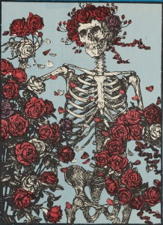

Skeleton Image
Mouse and Kelley found a black and white version of this skeleton and roses image while digging through library books. “We were fishing in the past, bringing up old stuff that should be seen again.” The artists added color and graphic lettering, and the image eventually became the emblem for the Grateful Dead. “Kelley had the unique ability to translate the music being played into these amazing images that capture the spirit of who we were and what the music was all about,” said Mickey Hart, drummer for the Grateful Dead.

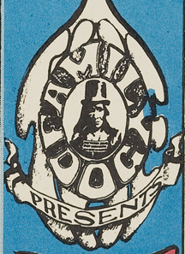

Family Dog Logo
Family Dog Productions was founded by Chet Helms and was used to promote concerts at the Avalon Ballroom. For their logo, Helms instructed poster-artist Wes Wilson to use an image of a Native American fur trader from the American Heritage Book of Indians. The hippies associated many ideas they admired, such as closeness to nature and communal living, with American Indian cultures. (Fun tip: try to decipher the word “THE” behind the logo.)

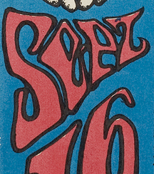

Lettering
Mouse’s skill at lettering comes from his experience designing hot rod graphics. He spent time painting pinstripes, flames, and letters onto old cars.

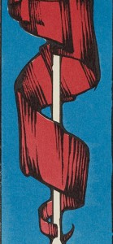

Ribbons
Notice the way that the artists created movement by drawing a ribbon twisting around a pole. They layered on black ink to create folds in the fabric so that the ribbon appears to be three-dimensional.

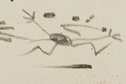

"Mouse"
Stanley Miller was given the nickname “Mouse” in high school after filling numerous sketchbook pages with drawings of cartoon mice. Look for Mouse’s characteristic signature at the bottom of the poster.
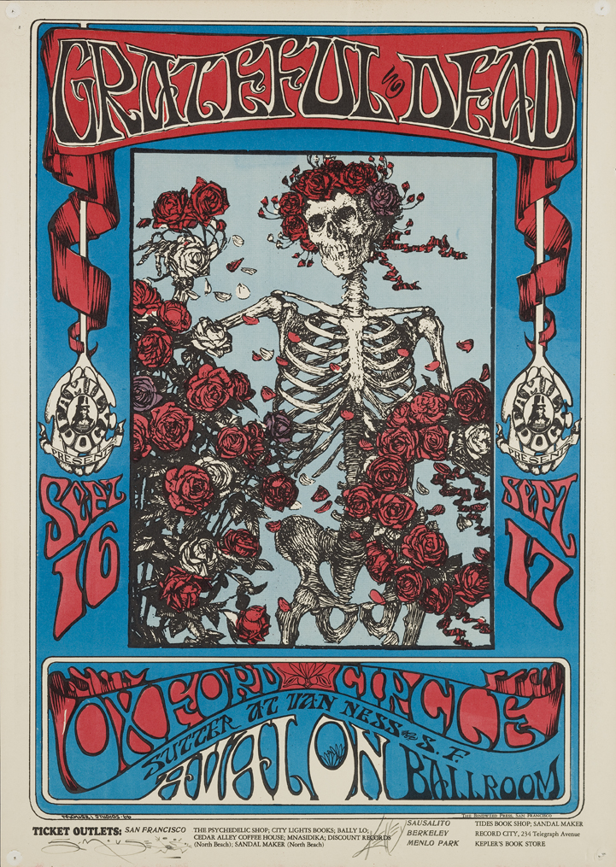
Skull and Roses/Grateful Dead, Oxford Circle, Avalon Ballroom, San Francisco
Alton Kelley and Stanley Mouse, United States
1966
Denver Art Museum: Partial gift of David and Sheryl Tippit; partial purchase with Architecture, Design, and Graphics Department Acquisition Funds; and Volunteer Endowment Funds in honor of R. Craig Miller; 2007.4368
© 2012 Rhino Entertainment
This image is intended for classroom use only and may not be reproduced for other reasons without the permission of the Denver Art Museum.
This piece may not currently be on display at the museum.
This Website is generously funded by a grant from the Morgridge Family Foundation. Additional funding is provided by the William Randolph Hearst Endowment for Education Programs, The Virginia Hill Charitable Foundation, Colorado Creative Industries and the National Endowment for the Arts, Xcel Energy Foundation, the Anna and John J. Sie Foundation, and The Japan Foundation. We thank our colleagues at the University of Denver Morgridge College of Education.
- See more at: http://creativity.denverartmuseum.org/?lesson-plan=jamming-and-fishing#sthash.iIgz4wy9.dpuf

